Business Requirements Document (BRD)
Project: OptimAlze Buddy - AI-Powered Digital Services Agent

Table of Contents
- Document Version History
- Executive Summary
- Project Overview & Public Sector Context
  - Digital Government Imperative
  - Problem Statement Deep Dive
  - Project Vision & Strategic Objectives
  - Project Scope (In-Scope / Out-of-Scope)
- Stakeholder Analysis & User Personas
- Solution Vision & Value Proposition
- Detailed Requirements Specification
  - Business & Process Requirements
  - Functional Requirements
  - Non-Functional Requirements
  - Data Requirements
- System Architecture & Technical Design
  - System Context Diagram
  - High-Level System Architecture
  - AI Agent Core Components
- Core Processes & Use Cases
  - End-to-End Citizen Service Journey
  - Agent Workflow Orchestration
  - Detailed Use Case Specifications
- Data Model & Knowledge Management
- User Interface & Experience Design
- Assumptions, Constraints & Dependencies
- Risk Assessment & Mitigation Strategy
- Appendices
  - Glossary of Terms
  - Service Category Matrix
  - Compliance Standards Reference

1. Document Version History
Version | Date | Author | Change Description
0.1 | 2023-10-19 | OptimAlze BA Team | Initial Draft
0.5 | 2023-10-23 | OptimAlze BA Team | Added architecture diagrams
1.0 | 2023-10-26 | OptimAlze Steering Committee | Final approved version

2. Executive Summary
Public service delivery stands at a critical juncture where citizen expectations for digital convenience clash with legacy government systems and processes. Despite significant investments in e-government portals, citizens continue to face fragmented, confusing, and time-consuming experiences when seeking basic services such as license renewals, permit applications, or accessing municipal information. This friction erodes public trust and burdens administrative staff with repetitive, low-value tasks.
OptimAlze Buddy represents a paradigm shift in public sector digital service delivery. It is an AI-powered digital services agent that transforms how citizens interact with government by providing a single, intelligent conversational interface. Unlike conventional chatbots that merely provide information, OptimAlze Buddy combines Retrieval-Augmented Generation (RAG) for accurate, policy-grounded answers with agentic workflows that can execute tasks (e.g., book appointments, submit forms) and intelligent document validation to pre-screen submissions in real-time.
This BRD outlines the requirements for a system designed to act as a "24/7 digital clerk," reducing administrative backlog by up to 40%, cutting citizen service resolution time by over 60%, and dramatically decreasing application rejection rates due to document errors. By serving as the unified front-end for municipal services, OptimAlze Buddy will elevate citizen satisfaction, optimize staff allocation, and accelerate the digital transformation of public service delivery.
3. Project Overview & Public Sector Context
3.1 Digital Government Imperative
Governments worldwide are mandated to deliver services efficiently, transparently, and equitably. The digital transformation of public services is no longer optional but essential. Key drivers include:
- Citizen Expectations: Digital natives expect government services to match the simplicity and responsiveness of private sector applications like banking or e-commerce.
- Operational Efficiency: Public agencies face budget constraints and staffing shortages, necessitating automation of routine inquiries and transactions.
- Inclusivity & Accessibility: A well-designed digital agent can provide consistent, 24/7 service in multiple languages, bridging gaps for non-technical or differently-abled citizens.
- Data-Driven Governance: Consolidated interaction data from an AI agent provides unprecedented insights into service demand patterns, pain points, and citizen needs.
3.2 Problem Statement Deep Dive
The current citizen-government interface is plagued by systemic inefficiencies:
- Information Fragmentation: Citizens must navigate multiple, often outdated websites and portals to find accurate information. A single query like "How do I get a parking permit?" may require visiting the tax, transportation, and local ward office sites.
- Process Complexity: Even when information is found, the process to complete a service (download form, fill, attach documents, submit, schedule appointment) is linear and brittle. One error (e.g., a missing signature) forces a restart, causing frustration and delays.
- Documentation Burden: A leading cause of application rejection (estimated at 25-40%) is incorrect, incomplete, or poor-quality supporting documents. Citizens receive no real-time guidance during upload, leading to submission loops.
- Staff Burnout and Inefficiency: Administrative staff spend 60-70% of their time on repetitive, transactional queries (status checks, appointment bookings, basic information) that could be automated, leaving less time for complex casework.
- Lack of Proactive Service: The service model is purely reactive. Citizens must know what they need and how to ask for it. There is no intelligent guidance based on life events (e.g., "You just had a baby, here are the 5 services you might need").
3.3 Project Vision & Strategic Objectives
Vision: To become the primary, trusted, and intelligent interface for all citizen-government interactions, making public service delivery seamless, proactive, and error-free.
Strategic Objective | Key Performance Indicator (KPI) | Target
Reduce Administrative Burden | Percentage reduction in routine inquiries handled by human staff | 40% reduction within 12 months
Improve First-Contact Resolution | Percentage of interactions resolved by AI without escalation | 70% resolution rate
Eliminate Document Errors | Reduction in application rejections due to document issues | 50% reduction
Enhance Citizen Satisfaction | Citizen Satisfaction Score (CSAT) | > 4.2 / 5.0
Increase Service Accessibility | Availability of services via agent | 24/7 availability, 95% uptime

3.4 Project Scope
In-Scope for MVP (Phase 1 - Municipal Pilot):
- A multilingual conversational web interface accessible via municipal website and mobile app.
- Integration with 3-5 high-volume service workflows:
  - Information Retrieval: Parking rules, waste collection schedules, office hours.
  - Appointment Booking: For in-person services at the municipal office.
  - Form Submission & Guidance: Digital assistance for 2 selected forms (e.g., Resident Registration, Parking Permit Application).
  - Document Validation: Real-time check for 3 document types (ID, Proof of Residence, Vehicle Registration).
- RAG system trained on the municipality's official policy documents, FAQs, and bylaws.
- Back-office dashboard for staff to monitor conversations, review escalations, and manage knowledge base.
- Basic analytics on query volumes, resolution rates, and common issues.
Out-of-Scope:
- Processing of payments or financial transactions.
- Integration with backend legacy case management systems (Phase 2).
- Outbound proactive notifications or marketing.
- Physical kiosk deployment.
- Services requiring complex legal judgment or discretion (e.g., welfare eligibility determination).
- Voice interface (text/chat only for MVP).

4. Stakeholder Analysis & User Personas
Stakeholder Group | Primary Influence/Interest | Key Goals & Motivations | Potential Concerns
Citizens/Residents (End User) | Service outcome, ease of use. | Get accurate information quickly, complete tasks without errors or multiple visits, save time. | Trust in AI accuracy, data privacy, accessibility for non-tech users.
Municipal Frontline Staff | Workload, job satisfaction. | Reduce repetitive queries, focus on complex cases, have a reliable tool to refer citizens to. | Fear of job displacement, increased complexity if tool fails, reliance on accurate knowledge base.
Department Heads & Managers | Operational efficiency, budget, performance metrics. | Meet service-level agreements (SLAs), reduce backlog, demonstrate innovation, improve citizen satisfaction scores. | Implementation cost, ROI, change management with staff, vendor lock-in.
IT & Digital Transformation Team | System integration, security, maintenance. | Choose a scalable, secure platform that integrates with existing tech stack, easy to maintain and update. | Compliance with government security standards (e.g., FedRAMP, local equivalents), API reliability, data sovereignty.
Policy & Legal Team | Compliance, risk management. | Ensure all agent responses are compliant with regulations, avoid liability from incorrect advice, manage data according to privacy laws (GDPR, etc.). | Hallucinations or inaccurate information, audit trail of interactions, consent management.
OptimAlze Development Team | Building a robust, scalable product. | Clear use cases, access to domain experts for training, well-defined success criteria. | Ambiguous government processes, difficulty accessing training data, strict change control processes.
Primary User Persona: "Busy Resident"
- Name: Maria Schmidt
- Role: Working parent, part-time student.
- Context: Needs to renew her parking permit but can only deal with government matters during evenings or weekends. Previously wasted an hour on the confusing website and had an application rejected due to a blurry document scan.
- Goals: Find the exact requirements, upload the right documents correctly the first time, and get a confirmed application without visiting city hall.
- Frustrations: Inflexible office hours, unclear instructions, fear of making mistakes.
5. Solution Vision & Value Proposition
OptimAlze Buddy is not a chatbot; it is an AI-Powered Public Servant. While generic chatbots provide scripted responses and simple FAQ matching, our solution is built on three core, integrated capabilities that create a truly intelligent agent:
- Accurate, Trustworthy Information (The Knowledgeable Clerk): Using Retrieval-Augmented Generation (RAG), the agent grounds every response in the municipality's actual policy documents, bylaws, and official databases. This eliminates hallucinations and provides citizens with citable, accurate information, building essential trust in public institutions.
- Action-Oriented Assistance (The Proactive Facilitator): The agent understands user intent and can orchestrate multi-step workflows. It doesn't just say "fill out Form XYZ"; it can guide the user through the form conversationally, pre-fill known data, and upon completion, submit it to the correct department or book the necessary follow-up appointment, transforming information into action.
- Intelligent Gatekeeping (The Quality Control Officer): Before a citizen submits an application, the agent uses computer vision and rules to validate uploaded documents in real-time. It can check for legibility, completeness, expiration dates, and format, providing instant feedback like "Your ID photo is too dark, please retake in better light." This prevents the most common cause of processing delays and rejections.
The value proposition is therefore tripartite:
- For Citizens: Simplicity, speed, and certainty in accessing public services.
- For Staff: Liberation from transactional tasks to focus on meaningful, complex citizen support.
- For Government: Higher operational efficiency, improved compliance, and enhanced public trust through transparent, consistent service delivery.
6. Detailed Requirements Specification
6.1 Business & Process Requirements
ID | Business Requirement Description | Priority | Associated KPI
BR-001 | The system must deflect at least 40% of routine informational and transactional inquiries (Tier 0) from human staff to the AI agent. | High | Staff Inquiry Deflection Rate
BR-002 | The system must provide 24/7 access to accurate, policy-grounded information for citizens, with responses traceable to source documents. | High | Information Accuracy Score (>95%)
BR-003 | The system must guide users through at least 5 defined service application workflows, reducing average completion time by 50% compared to the manual web form process. | High | Task Completion Time Reduction
BR-004 | The system must pre-validate uploaded documents in real-time, reducing document-related application rejections by 50%. | High | Document Error Reduction Rate
BR-005 | All citizen interactions must be logged and auditable to ensure compliance, provide insights for process improvement, and support staff escalations. | High | 100% Interaction Logging
6.2 Functional Requirements
Conversational Core Module:
ID | Requirement | Acceptance Criteria
FR-101 | Understand natural language queries | ≥ 90% intent accuracy
FR-102 | Retrieve answers using RAG | Answers include source citation
FR-103 | Detect action vs information intent | > 95% classification accuracy
Agentic Workflow Module:
ID | Requirement | Acceptance Criteria
FR-201 | Conversational form filling | Complete form without external help
FR-202 | Appointment booking integration | Booking confirmation returned
FR-203 | Submit applications to backend | Ticket/record generated
Document Intelligence Module:
ID | Requirement | Acceptance Criteria
FR-301 | Accept document uploads | Supports PDF, JPG, PNG up to 10MB
FR-302 | Validate documents via OCR & CV | Flags expired or incomplete docs
FR-303 | Provide instant validation feedback | Response within 5 seconds
Administration & Knowledge Module:
ID | Requirement | Acceptance Criteria
FR-401 | Admin console for monitoring | Conversation logs & analytics available
FR-402 | Knowledge base management tools | New content indexed within 1 hour
6.3 Non-Functional Requirements
- Performance & Scalability:
  - The system shall respond to 95% of conversational messages within 2 seconds.
  - The system shall support 100 concurrent user sessions during peak hours.
- Availability & Reliability: The public-facing chat interface shall have 99.5% uptime. Scheduled maintenance shall be communicated 48 hours in advance.
- Security & Compliance:
  - All data in transit and at rest shall be encrypted.
  - The system shall comply with relevant data protection regulations (GDPR, etc.). Citizen data shall not be used for model training without explicit, informed consent.
  - Full audit trails of all AI-generated responses and actions shall be maintained for a minimum of 7 years.
- Accessibility: The web chat interface shall be compliant with WCAG 2.1 AA standards to ensure accessibility for users with disabilities.
- Maintainability: The average time to update the knowledge base for a new policy or service shall be less than 4 hours of administrator work.
7. System Architecture & Technical Design
7.1 System Context Diagram
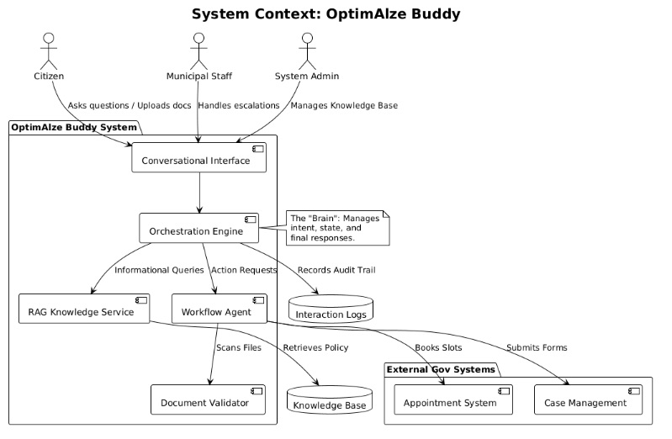
7.2 High-Level System Architecture
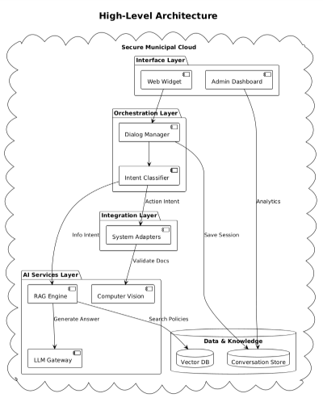

7.3 AI Agent Core Components
- RAG Pipeline: The system ingests PDFs, Word docs, and HTML pages from the municipal website. These are chunked, converted into vector embeddings, and stored in a vector database. For each query, it performs a similarity search to find the most relevant chunks, which are then passed as context to a Large Language Model (LLM) to generate an accurate, sourced answer.
- Workflow Execution Engine: A state machine that defines the steps for each service (e.g., "Apply for Permit"). It manages the conversation state, prompts the user for required information, triggers document validation, and calls the appropriate backend API via adapters. It is rules-driven to ensure strict compliance with process requirements.
- Document Validation Service: Utilizes pre-trained and custom computer vision models to perform:
  - OCR & Field Extraction: Reads text from IDs, certificates.
  - Quality Checks: Assesses blur, glare, and cut-off edges.
  - Rule-based Validation: Checks dates, presence of signatures/seals, and document type against expected templates.
- Dialog Manager: Maintains the context of the conversation across multiple turns, handling user corrections, topic switches, and managing the handoff between informational and action-oriented modes.
8. Core Processes & Use Cases
8.1 End-to-End Citizen Service Journey
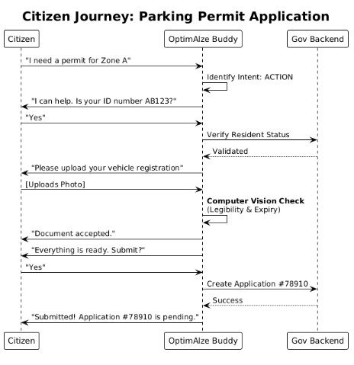
8.2 Agent Workflow Orchestration
The agent follows a deterministic yet flexible process for action-oriented requests:
- Intent Recognition & Workflow Selection: Identifies the desired service and loads the corresponding workflow definition.
- Pre-flight Eligibility Check: Asks qualifying questions or checks integrated databases to confirm the user is eligible for the service before proceeding.
- Step-by-Step Data Collection: Guides the user through each required field conversationally, providing clarifications as needed.
- Document Collection & Validation: Requests and validates each required document in real-time, allowing for immediate correction.
- Review & Confirmation: Presents a summary of collected data and documents for user confirmation.
- Execution & Feedback: Submits the package to the backend system and provides the user with a confirmation receipt and next steps.
8.3 Detailed Use Case Specifications
Use Case ID: UC-001
Use Case Name: Inquire About Waste Collection Schedule
Primary Actor: Citizen
Precondition: Citizen accesses the municipal website or app.
Main Success Scenario:
- Citizen clicks the "Ask OptimAlze" chat widget.
- Citizen types: "When is the green bin collected on Maple Street?"
- System uses RAG to search the latest waste management bylaws and collection zone maps.
- System identifies that Maple Street is in Collection Zone 4B.
- System retrieves the schedule: "Green bin (organics) is collected every Tuesday in Zone 4B."
- System generates response: "Based on the 2024 Waste Collection Schedule, residences on Maple Street (Zone 4B) should place their green organics bin out for collection every Tuesday. The next collection is tomorrow, October 24th. Please have bins out by 7 AM."
- Citizen receives the clear, actionable information.
Postcondition: Citizen's query is resolved without human intervention. Interaction is logged.
Alternate Flows: If the street name is ambiguous, the agent asks for the postal code to disambiguate.
9. Data Model & Knowledge Management
Core Data Entities:
Entity | Key Attributes | Purpose
Conversation | conversation_id, timestamps, escalation flag | Track chat sessions
Message | message_id, sender, intent, confidence | Audit conversation turns
Knowledge Chunk | chunk_id, source, embedding | RAG retrieval unit
Validated Document | doc_id, type, status | Store document validation
Workflow Instance | workflow_id, step, status | Track agent workflows

Knowledge Base Curation Process:
- Source Identification: Official websites, policy PDFs, internal procedure manuals, approved FAQ sheets.
- Ingestion & Chunking: Automated ingestion of documents, breaking them into logical chunks (e.g., by section).
- Enrichment & Tagging: Manual or semi-automated tagging of chunks with metadata: department, service type, effective date, geographic applicability.
- Vectorization: Generating embeddings for each chunk and storing in the vector database.
- Lifecycle Management: Processes to archive outdated chunks and highlight newly effective policies for review.
10. User Interface & Experience Design
Design Principles:
- Clarity Over Cleverness: Use simple, unambiguous language. Avoid bureaucratic jargon.
- Progressive Disclosure: Only ask for one piece of information at a time. Don't overwhelm the user.
- Mixed-Initiative Design: Allow users to answer questions in their own words but provide structured buttons (e.g., "Yes"/"No") for key decisions to reduce error.
- Transparent Process: Always indicate what step the user is on (e.g., "Step 3 of 5: Vehicle Details") and what will happen next.
- Seamless Handoff: If escalation to a human is needed, provide a smooth transition, transferring the full conversation history to the staff member.
Interface Components:
- Web Chat Widget: A minimally intrusive, always-available button on the municipal website that expands into a chat window.
- Mobile-Optimized Interface: Responsive design or dedicated section within the municipal mobile app.
- Back-Office Dashboard: A clean, searchable interface for staff to:
  - View real-time and historical conversation queues.
  - Take over escalated chats.
  - Access knowledge base management tools.
  - View analytics dashboards (volume, resolution rate, common topics).
11. Assumptions, Constraints & Dependencies
- Assumptions:
  - Municipal staff and policy experts will be available to validate the knowledge base and review the agent's responses during the pilot phase.
  - Citizens will have access to a smartphone or computer with a camera to upload documents.
  - The municipality has, or will create, digital versions of its key policy documents and forms.
  - Basic backend systems (e.g., for appointments) have APIs or can be adapted to integrate with the agent.
- Constraints:
  - Cannot make legally binding decisions (e.g., approve/deny permits). It can only submit applications for human review.
  - Must operate within strict government data sovereignty and privacy regulations, potentially limiting cloud hosting options.
  - Changes to government processes will require updates to the agent's workflows and knowledge base, creating an ongoing maintenance commitment.
- Dependencies:
  - Cooperation and buy-in from multiple municipal departments (IT, Legal, individual service departments).
  - Availability and stability of external LLM APIs or success in deploying a capable open-source model on-premise.
  - Existence of, or budget for, integration adapters to legacy municipal systems.
12. Risk Assessment & Mitigation Strategy
Risk | Probability | Impact | Mitigation Strategy
Inaccurate/Hallucinated Information | Medium | High | Implement a rigorous RAG pipeline with source citation. Establish a human-in-the-loop review for all new knowledge chunks and a monthly accuracy audit of sampled conversations.
Low Citizen Adoption & Trust | High | High | Launch with a clear communication campaign emphasizing the agent's role as an assistant, not a replacement. Ensure the UI is extremely simple and offer easy escalation to a human. Start with low-risk, high-volume services to build trust.
Staff Resistance & Change Management | High | Medium | Involve frontline staff in the design and testing phases from the beginning. Position the agent as a tool to eliminate their most tedious tasks, freeing them for more rewarding work. Provide comprehensive training.
Integration Failures with Legacy Systems | High | High | Adopt an adapter-based integration architecture. For Phase 1, choose workflows that have simple digital endpoints or are willing to accept submissions via email/queue as a fallback.
Data Privacy & Security Breach | Low | Critical | Design with "privacy by design" principles. Encrypt all data, implement strict access controls, conduct regular security audits, and ensure all hosting complies with government security standards.
Inability to Handle Complex/Edge Cases | Medium | Medium | Implement a robust intent classification and confidence scoring system. Low-confidence or highly complex queries must be smoothly escalated to human staff with full context transfer. Continuously log edge cases to improve the agent.

Document Approval
Role | Name | Signature | Date
Municipal Project Sponsor
Lead Business Analyst
Lead Solution Architect
OptimAlze Project Manager

